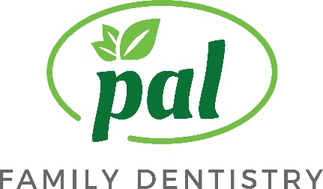

Written Financial Policy

Thank you for choosing Pal Family Dentistry. Our primary mission is to deliver the best and most comprehensive dental care available. An important part of the mission is making the cost of optimal care as easy and manageable for our patients as possible by offering several payments options.

PAYMENT OPTIONS:
You can choose from:
--Cash, Check, Visa, Master Card, Discover or American Express
--No interest Payment Plans ** from Care Credit
-- Allow you to pay over time with NO INTEREST*
-- Convenient, low monthly payment plans**also available
--No annual fees or pre-payment penalties

Please note:

Pal Family Dentistry requires payment prior to the completion of your treatment. If you choose to discontinue care before treatment is complete, you will receive a refund less the cost of care received.

For patients with dental insurance, we are happy to work with your carrier to maximize your benefits and directly bill them for reimbursement for your treatment.***

A fee of $50 is charged for patients who miss or cancel an appointment without 24-hours notice.

Pal Family Dentistry charges $25 for returned checks.

If you have any questions, please do not hesitate to ask. We are here to help you get the dentistry you want or need. Your signature below acknowledges understanding or this policy.

_______________________________________________________________
Patient, Parent of Guardian Signature Date

_______________________________________________________________
Patient Name (please print)

*If paid within the promotional period. Otherwise, interest is assessed form the purchase date. Monthly payment required.
**Subject to credit approval.
***However, if we do not receive payment from your insurance carrier within 60 days, you will b e responsible for payment of your treatment fees and collection of your benefits directly from your insurance carrier.

Pal Family Dentistry 11711 Bowman Green Drive Reston, VA 20190
Phone: 703-437-8337 Fax: 703-437-8339 Email: reston@palfamilydentistry.com www.palfamilydentistry.com

