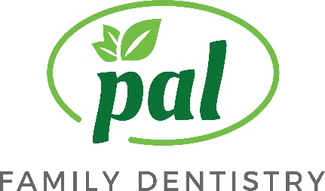

A Note About Insurance:

Unlike medial insurance, dental insurance is designed to assist you with dental expenses. Your employer chooses plans based on cost and benefits. These plans typically have percentage co-payments as opposed to flat fee (i.e. $10,$20.) Bear in mind that our relationship is with you and not with your insurance company. We have no leverage or influence on benefit determination, covered procedures or payments. Feel free to bring your benefit booklet with you and we will be happy to assist you in understanding your plan.

FEES: As a provider for most PPO insurances, we charge fees set by your PPO plan. We do not charge above the contract and allowable fee.

ELIGIBILITY: As a courtesy, we contact your insurance company to verify the specifics of your plan. We also file a claim for services rendered. Every effort is made to correctly estimate your co-pay for our visit.

CO-PAYMENT: Your co-payment, if any, is due at the time services are rendered. This co-payment is an estimate and final financial responsibility is determined once the insurance payment has been posted to y our account. In the event that the co-payment was underestimated, a statement will be sent for any balance remaining.

I have read and understand the above information.

_____________________________________________________________________
Patient/Guardian Date

Pal Family Dentistry 11711 Bowman Green Drive Reston, VA 20190
Phone: 703-437-8337 Fax: 703-437-8339 Email:reston@palfamilydentistry.com www.palfamilydentistry.com

