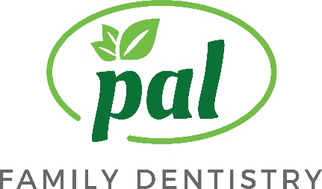
Informed Consent for General Dental Procedures

Thank you for choosing our dental office for your dental care. We will work with you to help you achieve excellent oral health. While recognizing the benefits of a pleasing smile and well functioning teeth, you should be aware that dental treatment, like treatment of any other part of the body, has some inherent risks. By consenting to treatment, you are acknowledging your willingness to accept known risks and complications, no matter how slight the probability of occurrence. These are seldom great enough to offset the benefits or treatment but should be considered when making treatment decisions. Here are some common risks associated with virtually any dental procedure:
1. Drug or chemical reaction: Dental material and medications may trigger allergic or sensitivity reactions.
2. Long-term numbness (paresthesia) : Local anesthetic, or its administration, while almost always adequate to allow comfortable care, can result in transient, or in rare instances , permanent numbness.
3. Muscle or joint tenderness: Holding one’s mouth open can result in muscle issues or in a predisposed patient, precipitate a TMJ disorder.
4. Sensitivity in teeth or gums, infection, or bleeding.
5. Swallowing or inhaling small objects.
6. Changes in treatment plan: During the course of treatment, it may be necessary to change or add procedures because of conditions found while working on teeth that were not discovered during examination.
While we follow procedural guidelines which most often lead to clinical success. Just like in any other pursuit in health care, not everything turns out as planned. We will do our best to assure that it does. Please feel free to ask questions in regard to all dental procedures that are recommended to you.
You, the patient, have the right to accept or reject dental treatment recommended by your dentist. Prior to consenting to treatment, you should carefully consider the anticipated benefits, commonly known risks of the recommended procedure, alternative treatments, or the option of no treatment.
Please read and INITIAL after ALL the items below. During my course of treatment the following procedures may be provided:
Examinations__________ Preventative Services _____________ Restoration _____________
Crowns _____________ Bridges ______________ Removable Appliance ________________
Amalgam Allowance For Composite Restorations: To help our patients make a more informed and educated decision regarding their dental care, we would like to explain an amalgam allowance. This is a provision in dental coverage through most insurance plans. An amalgam allowance is when a composite (tooth colored) filling is placed on a back tooth, but the insurance will only pay for it at the amalgam (silver) filling allowance (cost). This allowance does not apply to front teeth; front teeth are considered to be paid the usual and customary fees. The cost of the composite fillings is higher compared to amalgam; the price difference depends on the size of the restoration and the coverage on your insurance plan.
I have read and understand the statements on this page.
X____________________________________________ Date_______________________
Print name ________________________________________________________________

Pal Family Dentistry 11711 Bowman Green Drive Reston, VA 20190
Phone: 703-437-8337 Fax: 703-437-8339 Email:reston@palfamilydentistry.com www.palfamilydentistry.com

